http://REAP-eastafrica.org

REAP@ukonline.co.uk

18 Yewhurst Close, Twyford,
RG10 9PW

Registered Charity 1075121

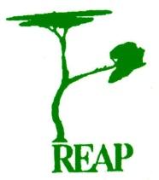

Rural Extension with Africa’s Poor

A Christian approach to development
through teaching

REAP’s Home Story

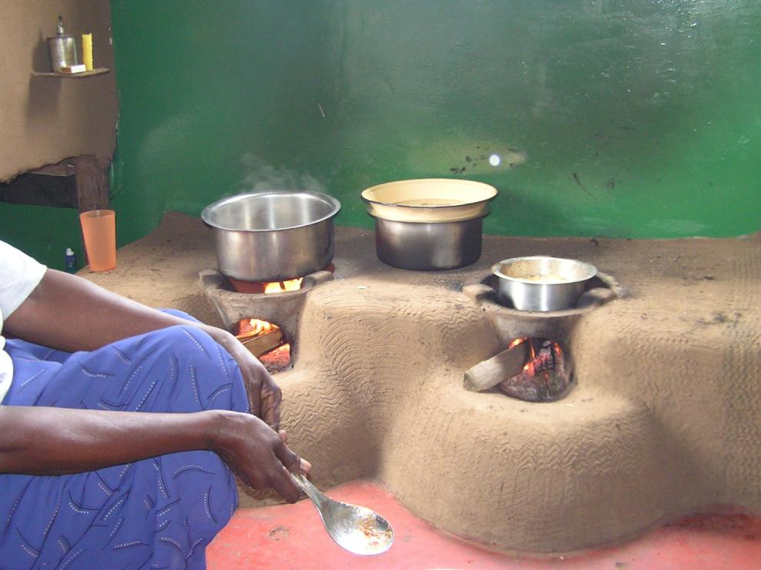

Learning how to provide for the family…

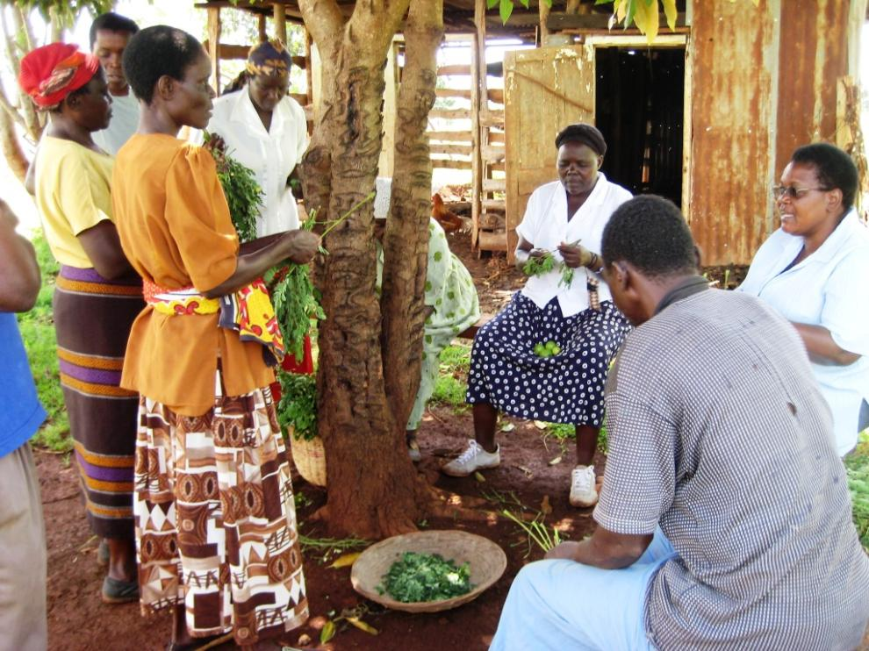

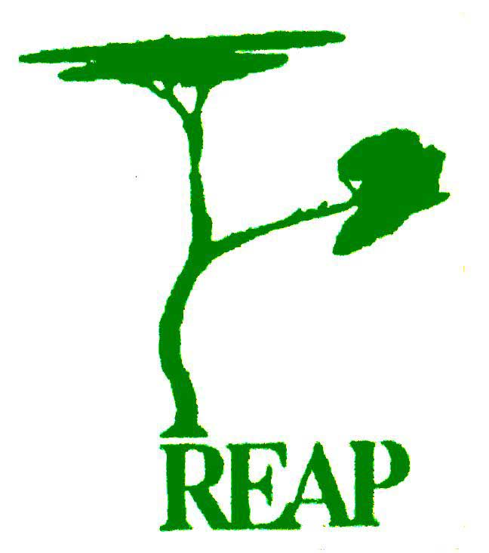

Knowing how to make living easier…

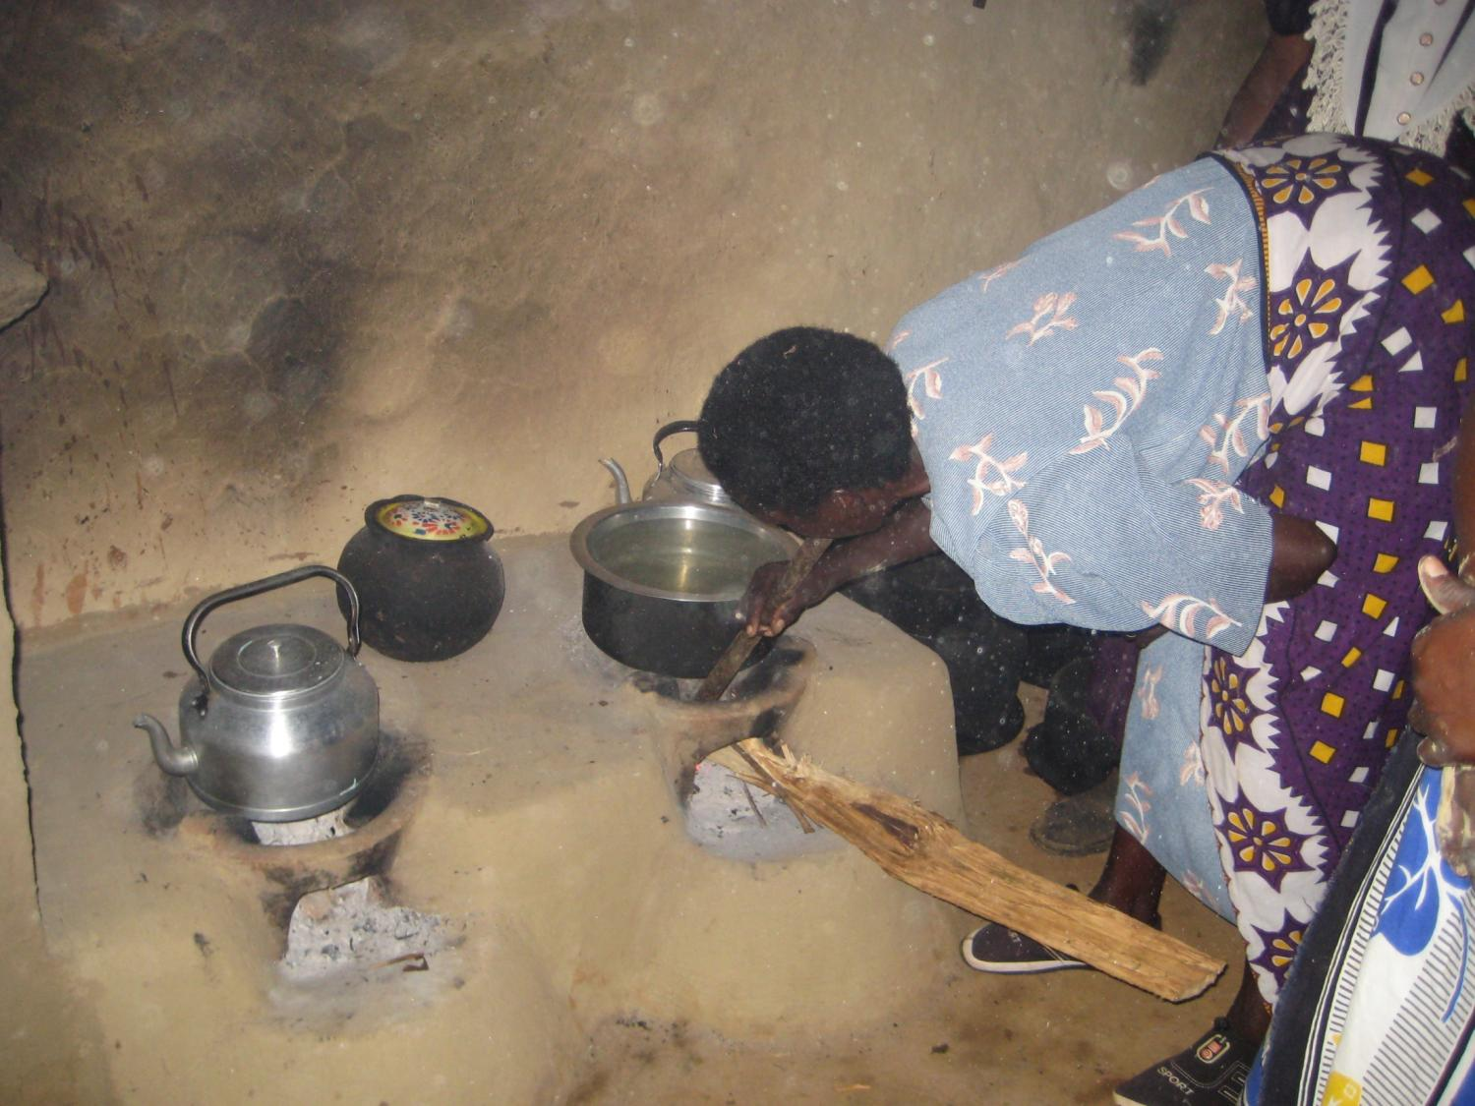

brings improvements to the home

One way that REAP has been very effective in changing the lives of the rural poor has been in the home

The differences that REAP’s teaching makes brings pride to Africa’s poor as they gain self respect and dignity

REAP has witnessed whole communities transformed as they have grown in confidence and wellbeing

Becoming aware of new skills…

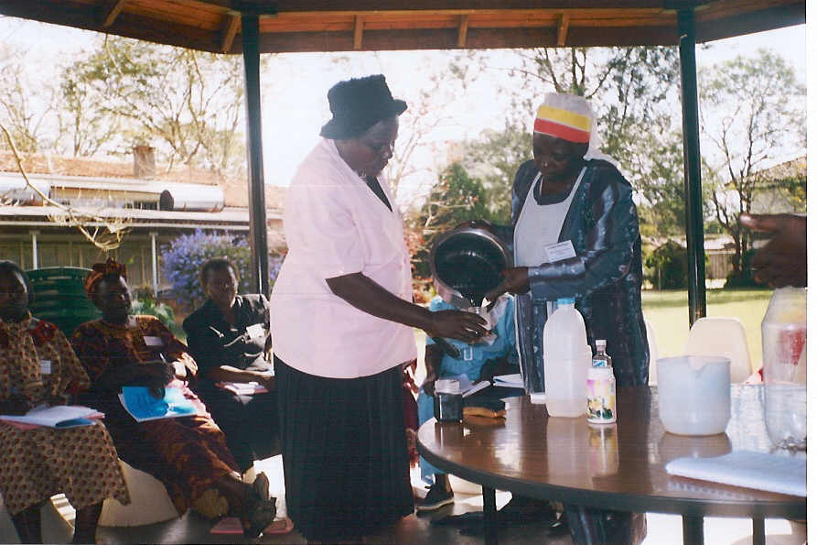

Making new things from old…

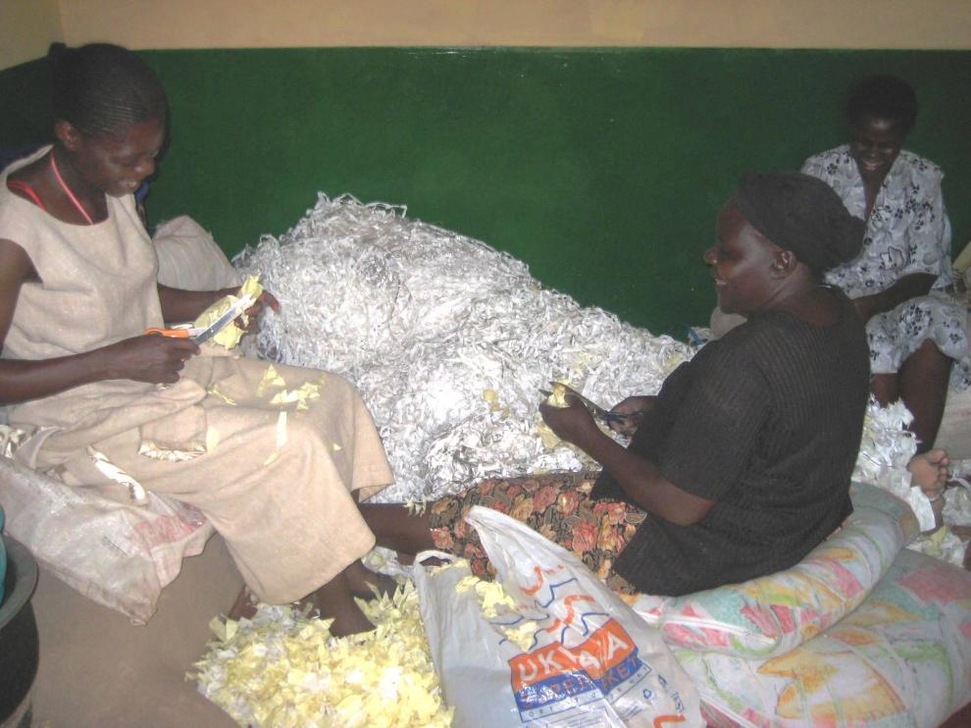

Building self esteem…

