http://REAP-eastafrica.org

Email: REAP@ukonline.co.uk
18 Yewhurst Close, Twyford, RG10 9PW

Registered Charity 1075121

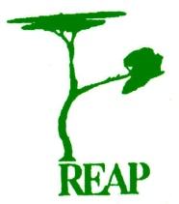

Rural Extension with Africa’s Poor

A Christian approach to development
through teaching

REAP’s Agricultural Story

Tithonia – used as a fertilizer
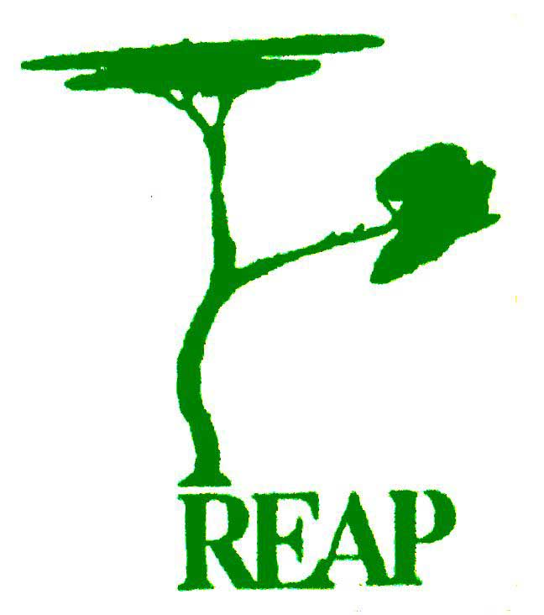 seeks to improve the lives of Africa’s rural poor through teaching how to use locally available resources

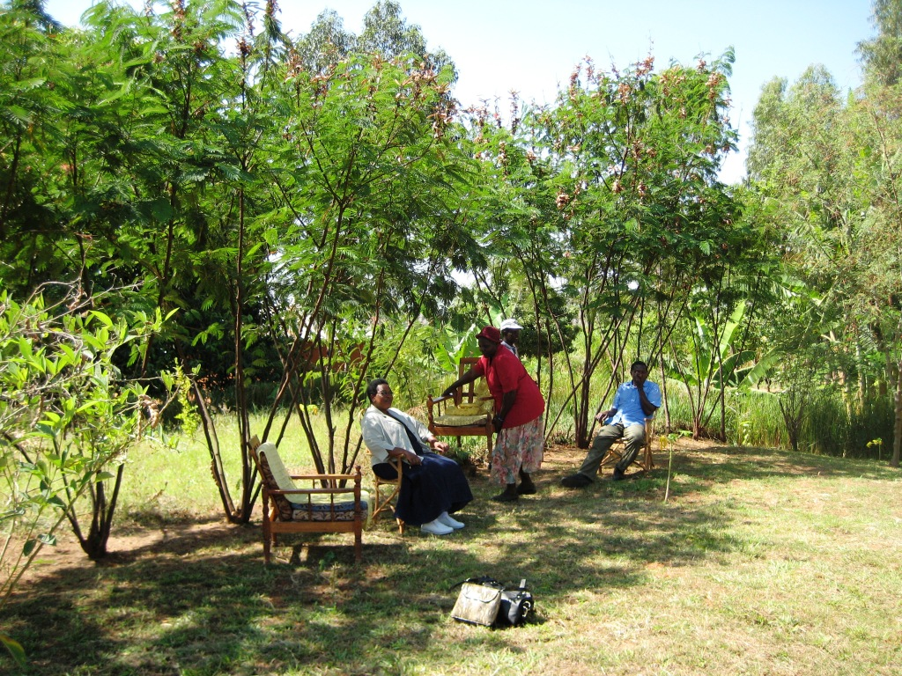

is concerned for the wellbeing and dignity of the individual as well as the whole of creation

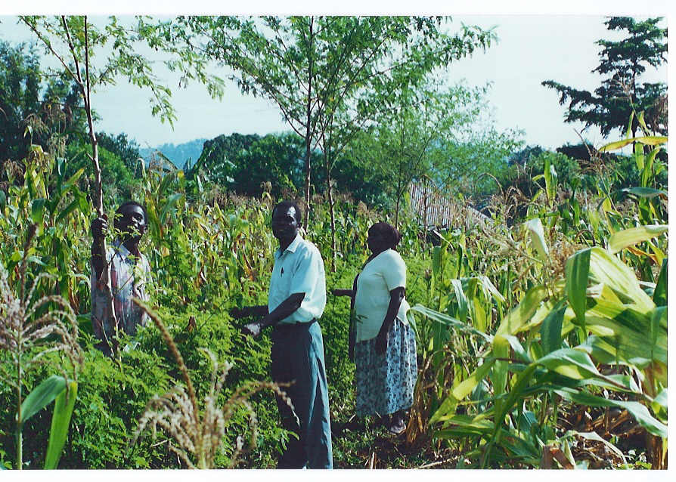

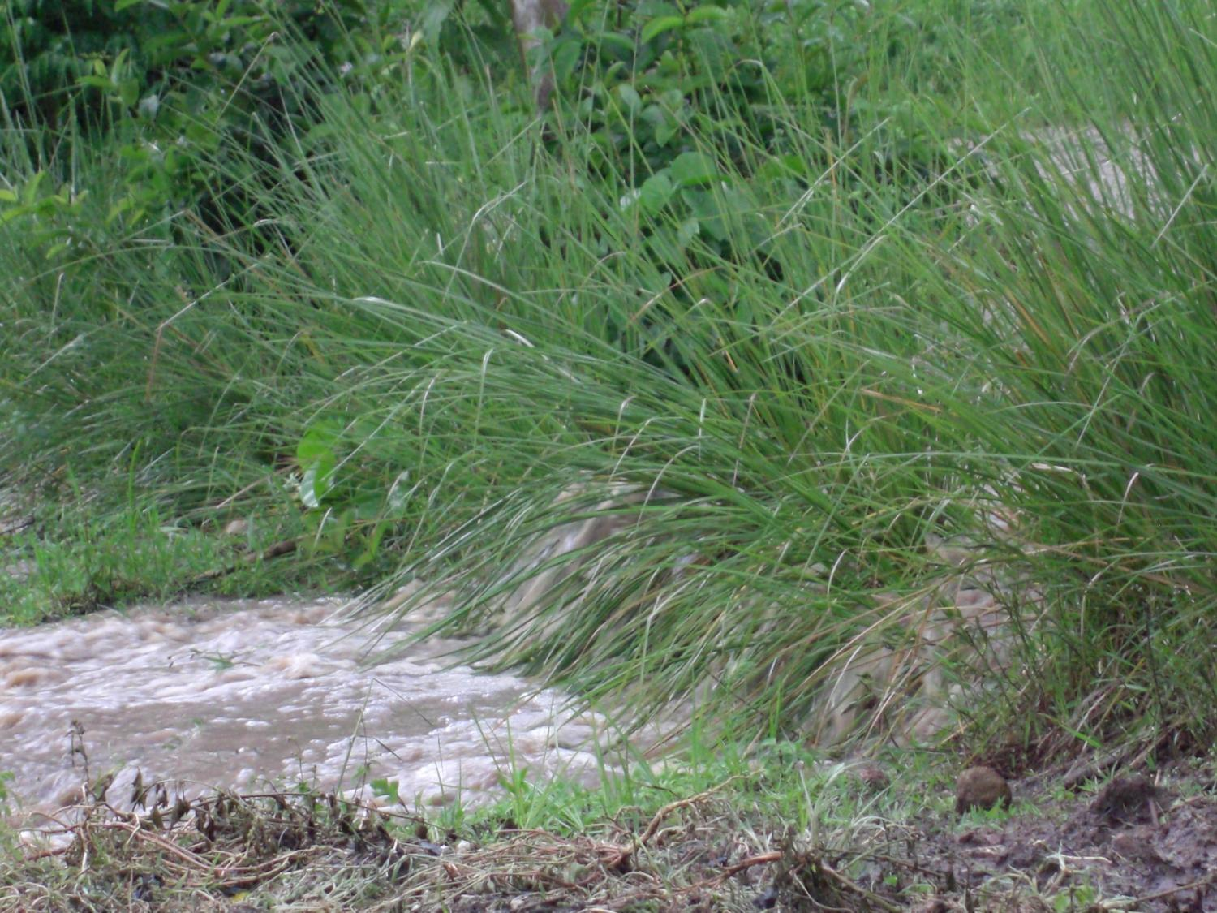

By using Vetiver as a terracing medium many inches of soil can be retained, which would otherwise have been lost. Soil brought down the hillside from higher up is stopped from going any further and adds to the fertile ground. These advantages are significant and REAP’s teaching is becoming highly valued as farmers realize how much the planting of Vetiver can improve their plots.

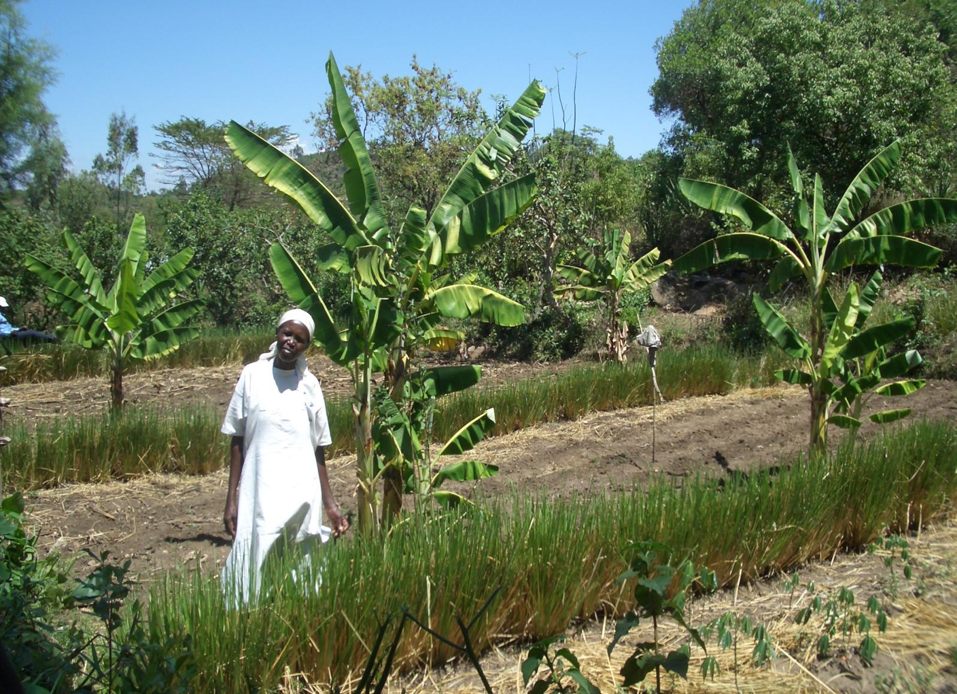
teaches good stewardship of God-given resources will enable the poor to improve their standard of living
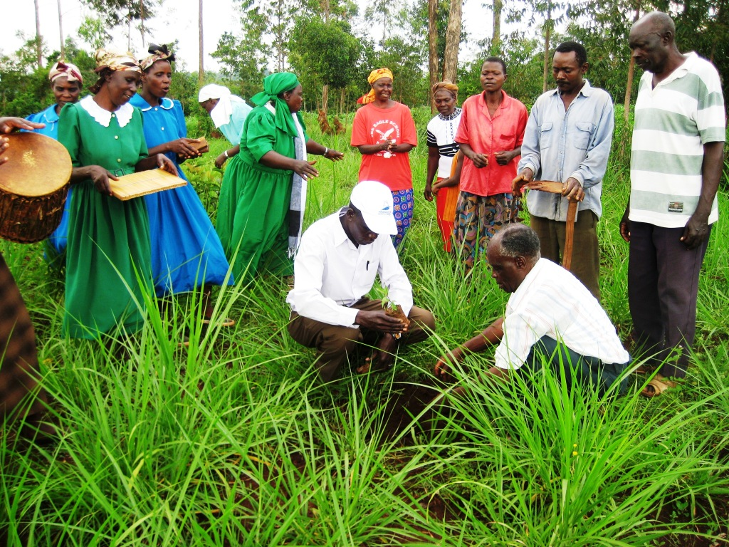

works to overcome a culture of dependency and the call for large external resources

