Rural Extension with Africa’s Poor
A Christian approach to development through teaching

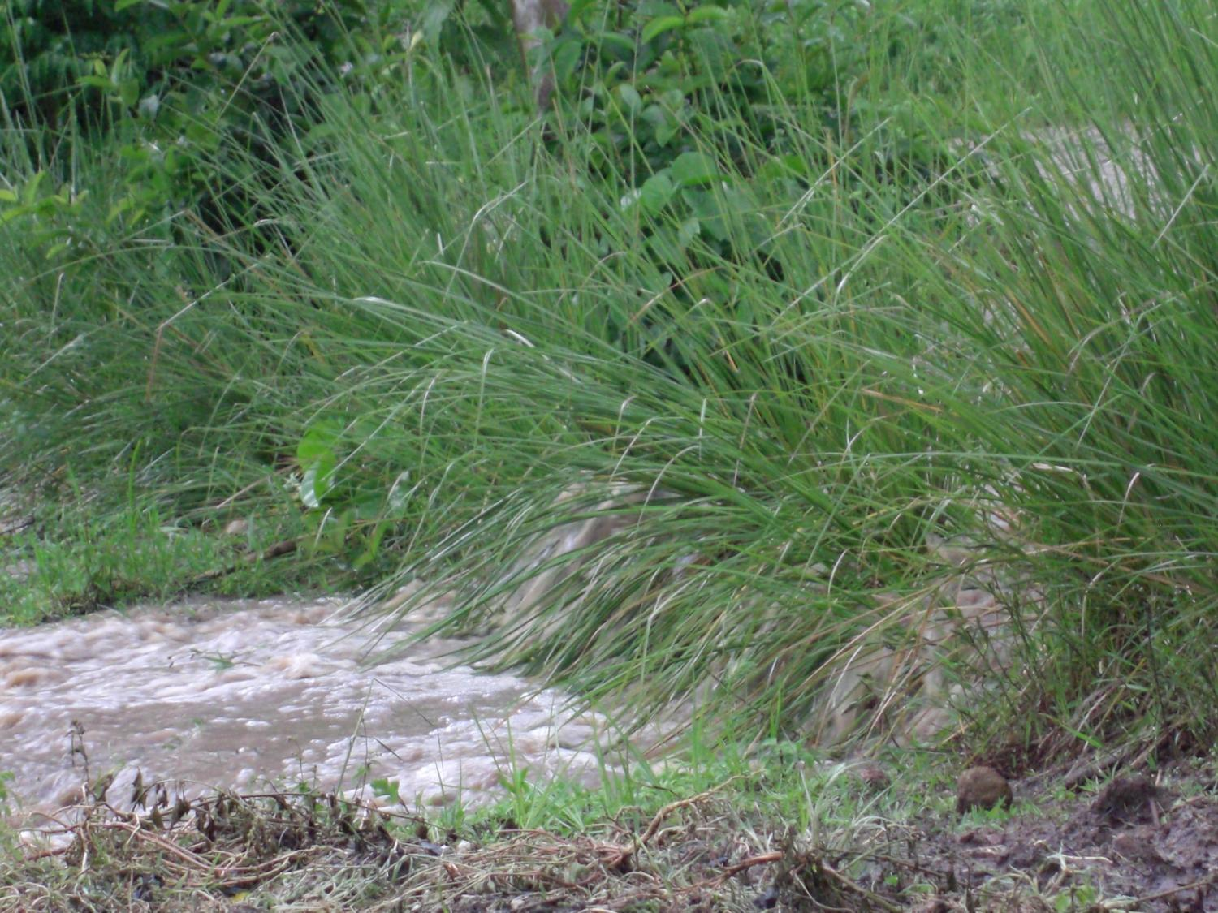
REAP’s Agricultural Story 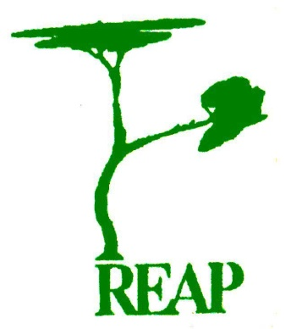
Presentation to be held at St John’s, Manchester
on 21st June, at 7.30 pm

