Rural Extension with Africa’s Poor
A Christian approach to development through teaching
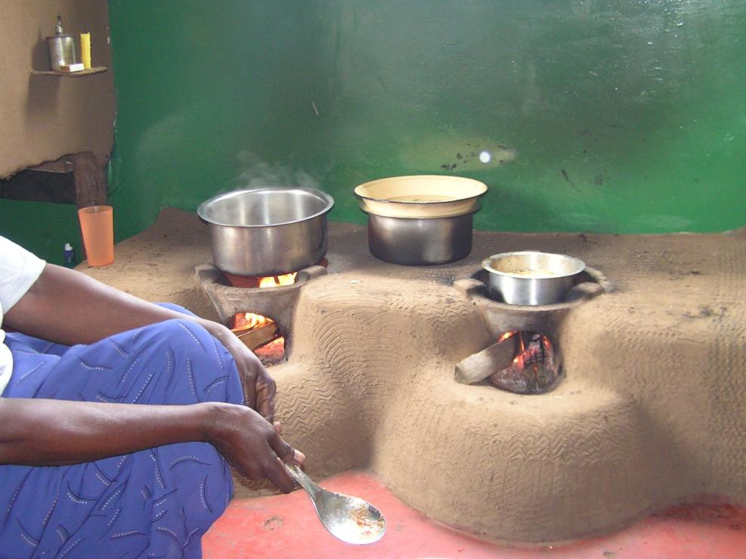
REAP’s Home Story 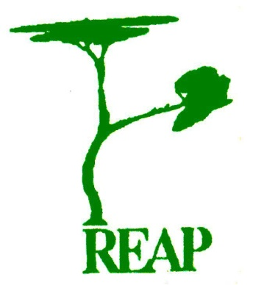
Presentation to be held at Greyfriars Church, Reading
on 30th August, at 11.30 am

