http://REAP-eastafrica.org

REAP@ukonline.co.uk

18 Yewhurst Close, Twyford,
RG10 9PW

Registered Charity 1075121

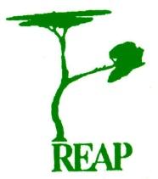

Rural Extension with Africa’s Poor

A Christian approach to development
through teaching

REAP’s
Natural Medicines Story

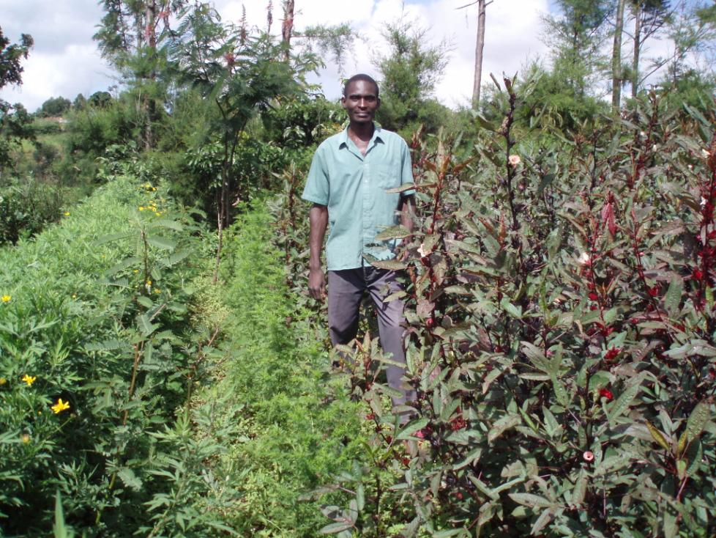
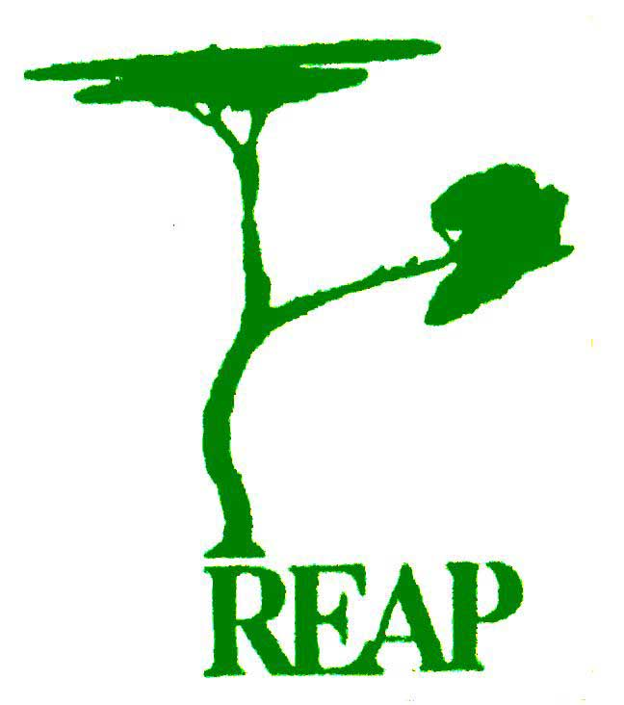brings healing to the home…

artemisia cures malaria

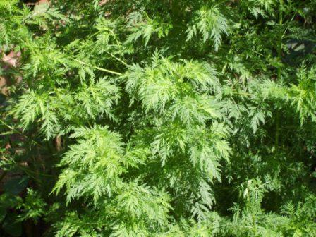

chilli ointment helps rheumatics

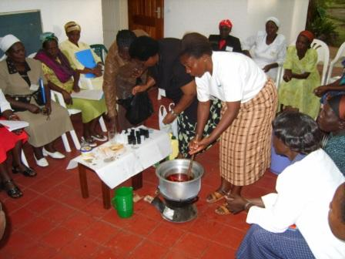

and ANAMED (Action for NAtural MEDicines) seek to combine modern scientific knowledge with traditional practices to use the best of both worlds

Scientific understanding provides information on dosages, limitations and side effects, whereas locally grown plants offer easy access at little cost

The negative aspects of mass produced pharmacetical products and tribal customs are covercome by providing knowledge free from both commercial exploitation and manipulative purposes

black stones remove bites and stings

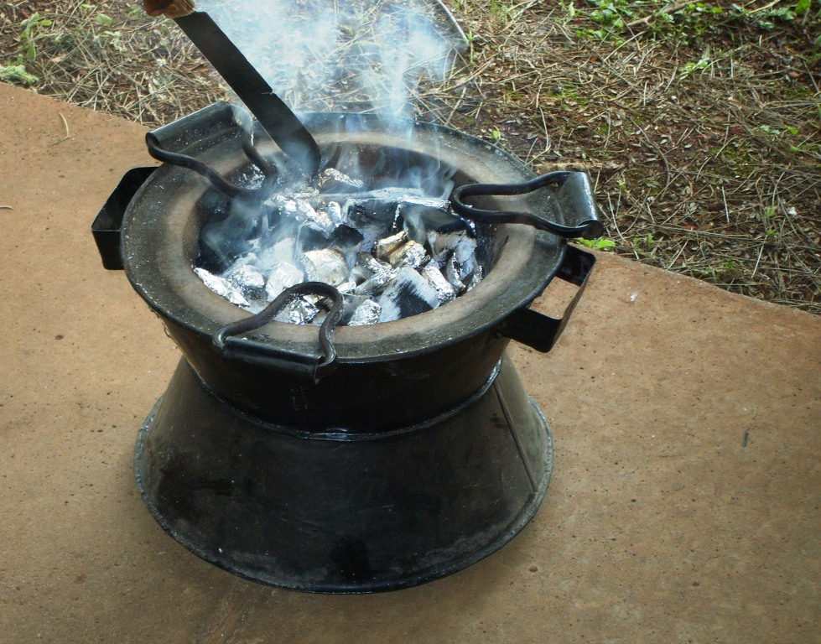

aloe vera gives fast relief from burns

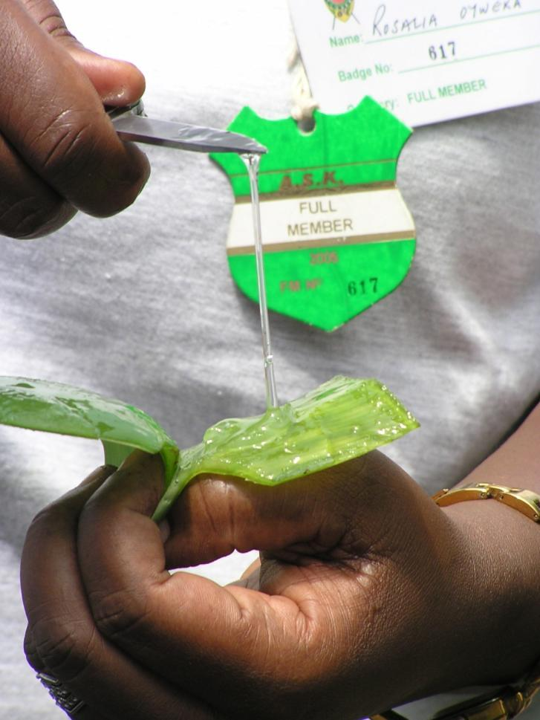

pawpaw treats wounds and intestinal worms

