Rural Extension with Africa’s Poor
A Christian approach to development through teaching
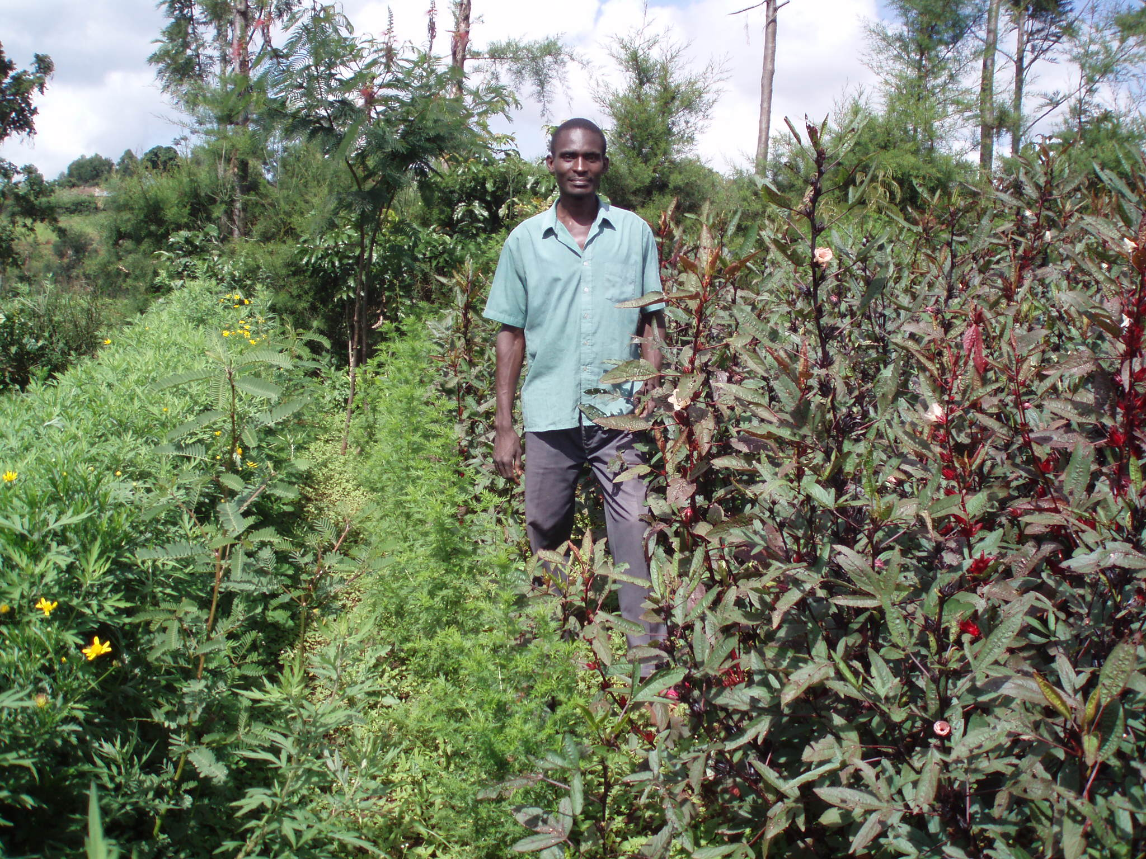
REAP’s Natural Medicines Story
Presentation to be held at St Peter’s  on 17th June at 6.30 pm | 