http://REAP-eastafrica.org

Email: REAP@ukonline.co.uk
18 Yewhurst Close, Twyford, RG10 9PW

Registered Charity 1075121

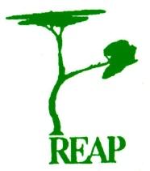

Rural Extension with Africa’s Poor

A Christian approach to development
through teaching

REAP’s Story

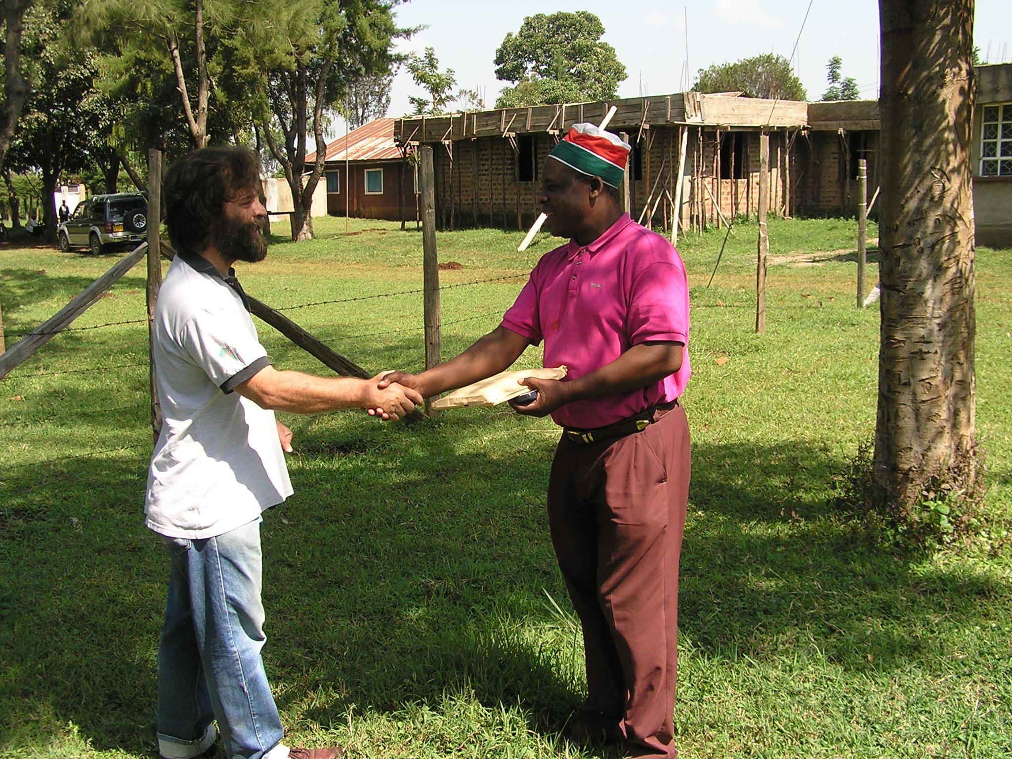

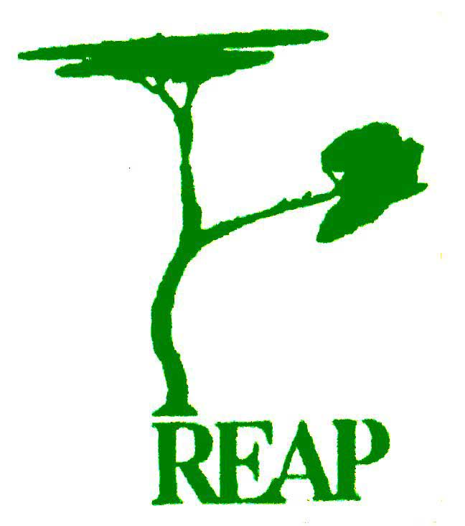 vision

To develop and implement a distinctively Christian approach to development

To enable Africa’s poor to reach their full potential and become good stewards of God’s creation without using external resources

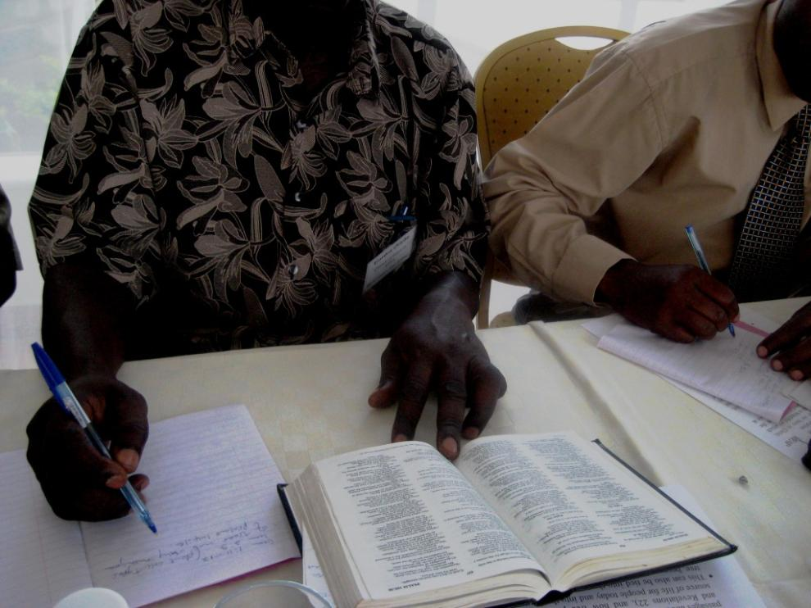

finds ideas

REAP discovers ways in which they can efficiently use resources that are readily available with little or no cost

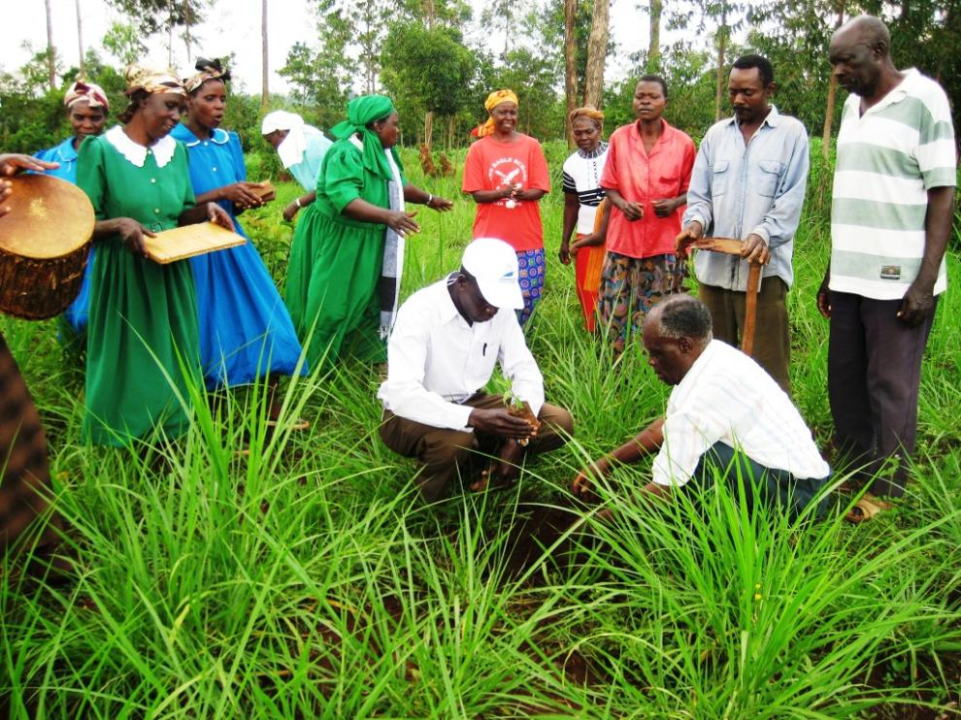

refines ideas

REAP refines teaching by discovering ways appropriate to the region, climate and customs of the people that they are addressing

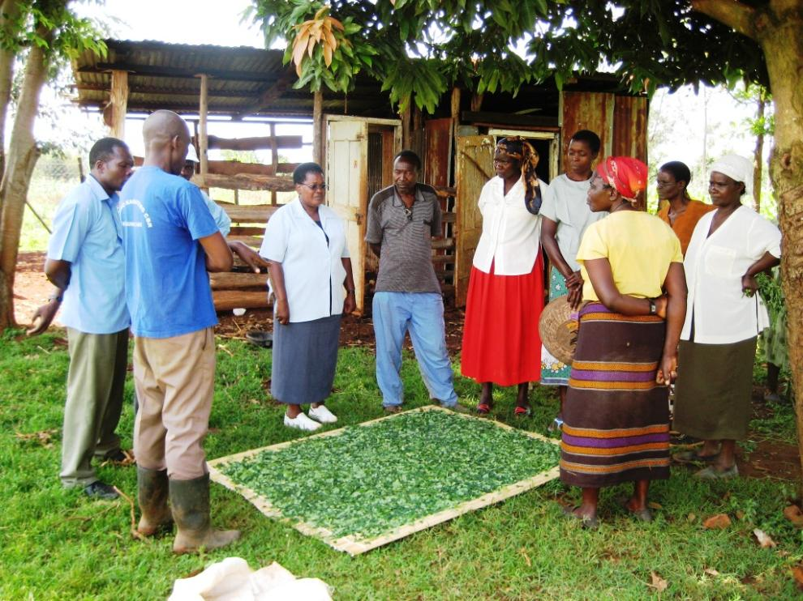

shares ideas

REAP demonstrates its ideas through its many contacts via individual farms, churches, workshops, nurseries and agricultural shows

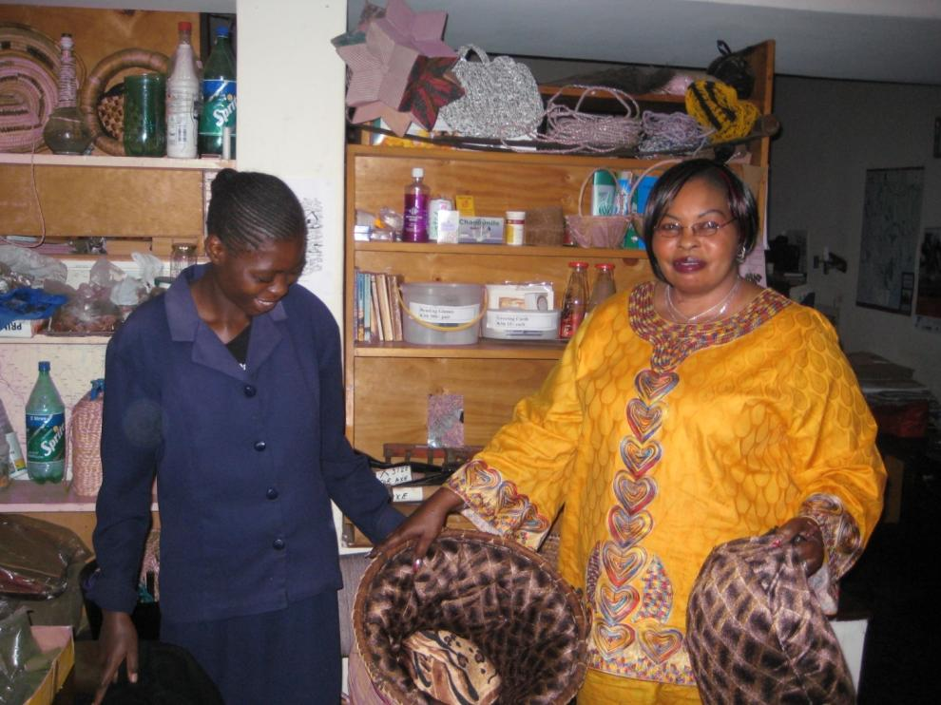

sustains ideas

REAP’s team continues to interact with those who have implemented their teaching to ensure that the concepts continue to be effective

