Rural Extension with Africa’s Poor
A Christian approach to development through teaching
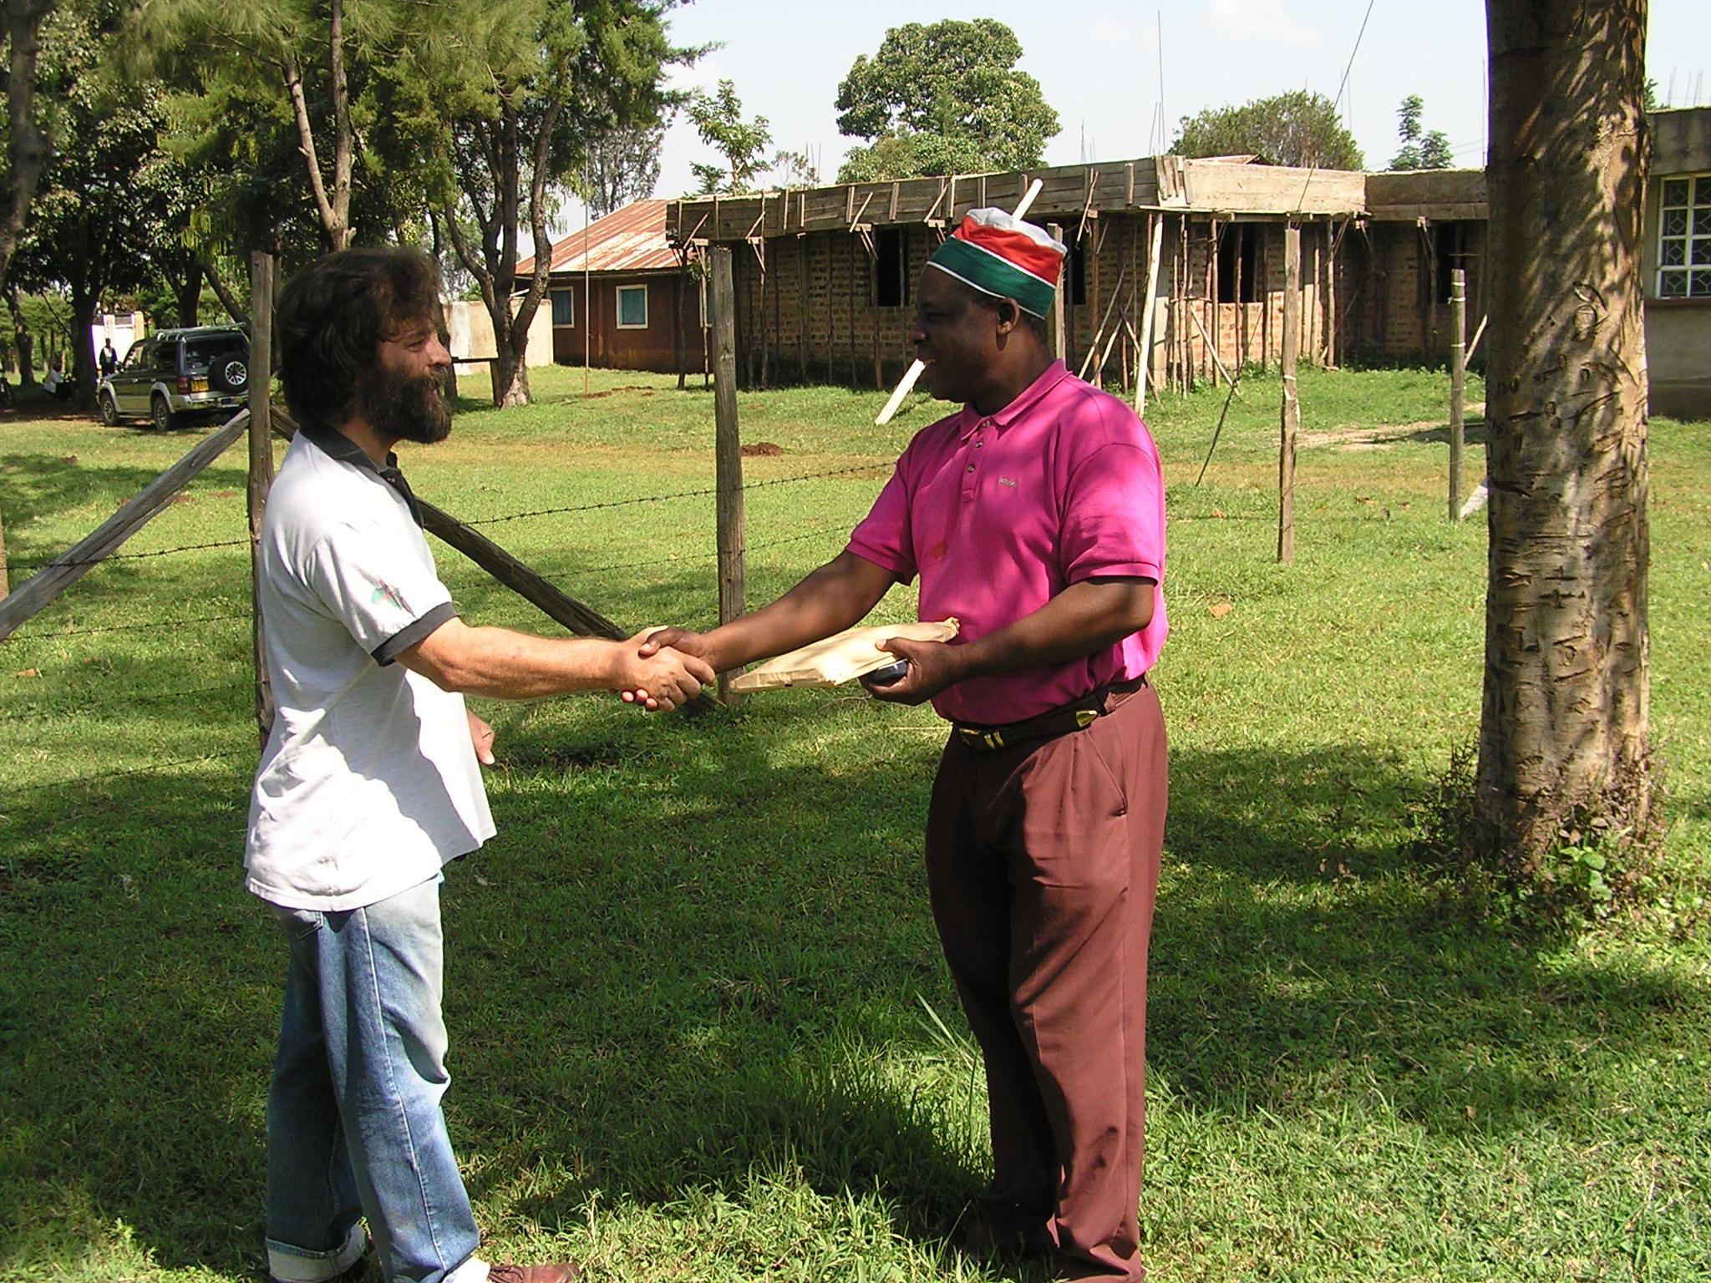
Learn about REAP 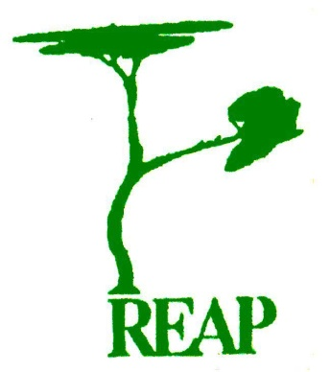
Presentation to be held at St Mary’s, on 24th February at 7.30 pm

